LAB 01: Chess Design Document

# Structure Chart

## Diagram, engineering drawing Description automatically generated Data Flow Diagram

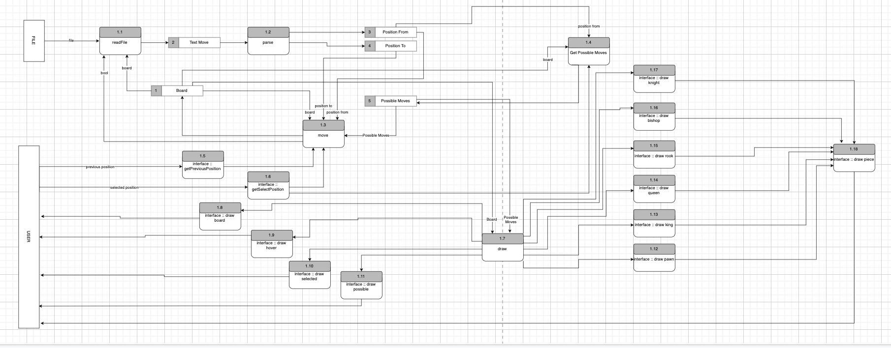

# Class Diagrams

RC Struct:  
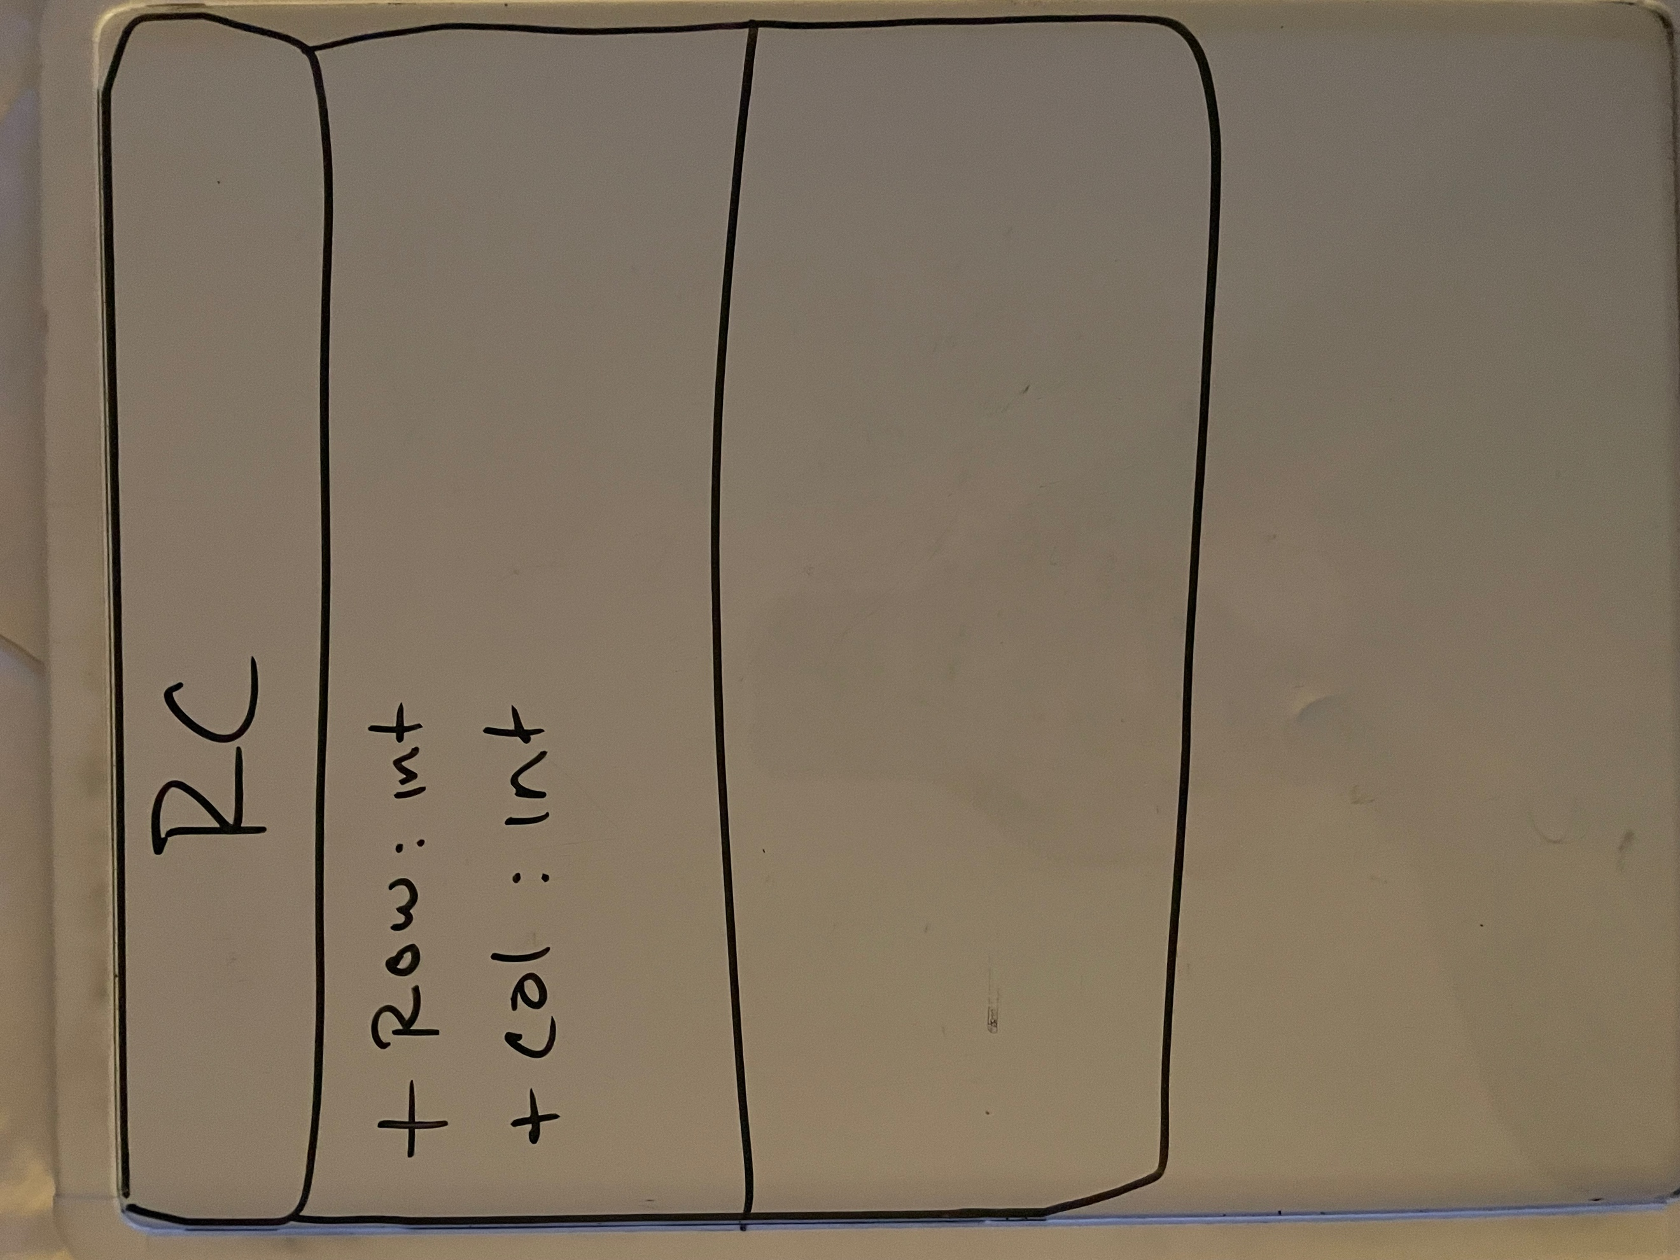

Point Class:

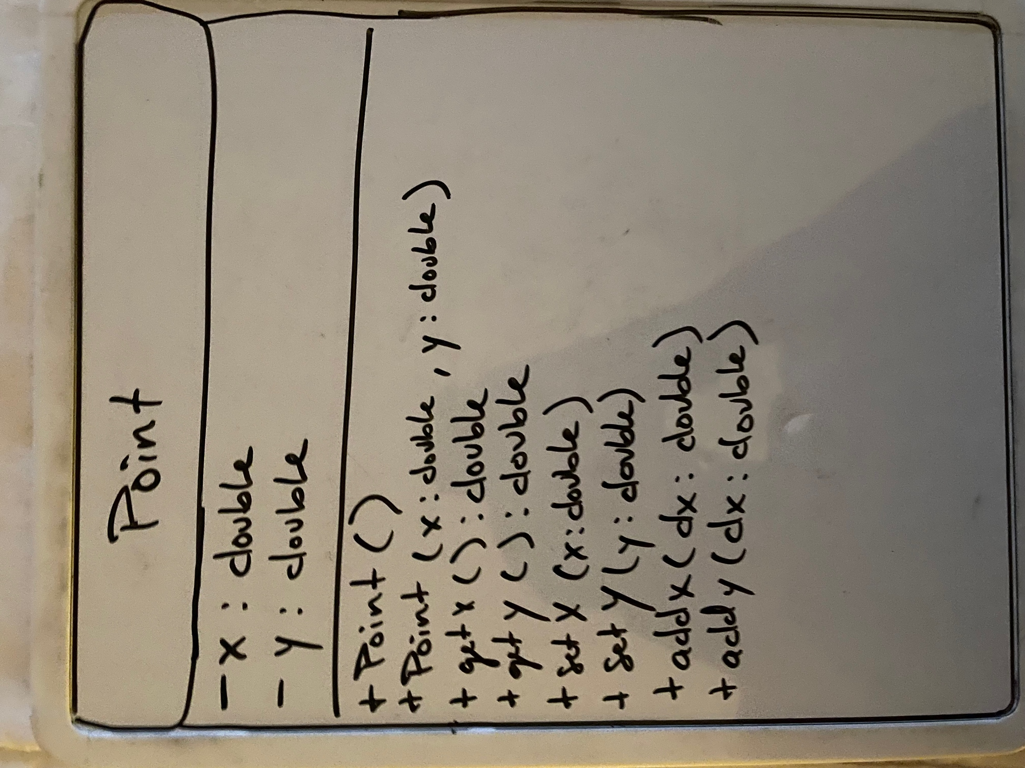  
  
  
  
  
  
  
  
  
  
  
  
Ogstream Class:

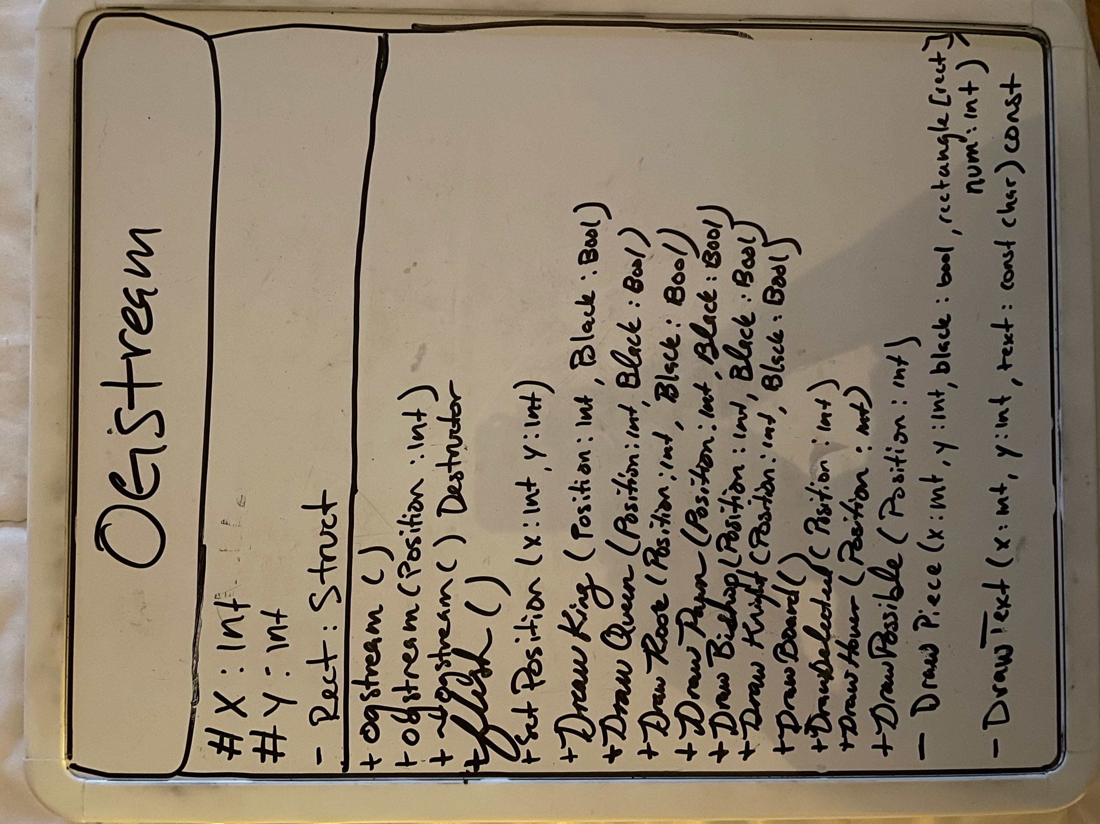

Interface Class:

